Dear Senior High students & parents,

Welcome (or welcome back) to Senior High! We hope you had a wonderful summer, and we look forward to spending time together again this school year!
Here’s what you can expect when Student Ministry (CFCSM) resumes in September:
SUNDAY MORNING “ENCOUNTER”: Our Sunday school ministry, which we call “Encounter”, is at 9:30am beginning on September 11th. This year, we will meet in Room 10 in the hallway behind the Gym just after all of the pastoral offices & just before the main youth room. The idea & emphasis is to encounter God & His written word on a more comprehensive basis than our other kinds of gatherings. This school year we will continue going through our 3-year Bible curriculum from The Gospel Project which we started last year, with some exceptions and mini-series at select times during the year.
SUNDAY NIGHT “TRANSFORM”: Beginning September 11th, is on Sunday nights from 7:00-8:45pm meeting in the Gym & the newly renovated youth room behind the Gym. Transform is a time to relax and build relationships with each other and with God; it’s also a great opportunity to invite friends! We’ll play games, eat snacks, meet in small groups and have a time of biblical instruction.
“IMPACT”: Is a part of CFCSM, one that we’re excited to see grow again this year. These are our intentional outreach and service events throughout the year. Opportunities to serve one another, our fellow believers, our neighbors, and reach out to those in need, those questioning life, the unbelieving & unreached. We’re looking into ways to present opportunities for students to serve one another, this church family, our community, our missionaries & potentially partner with local ministries & go on a mission trip next summer. Stay tuned for Impact events coming up this year!
CFCSM believes in having a healthy and sustainable ministry. We know that ministry needs to have its highs and lows (less busy times). For this school year we are currently planning to have 3 “high” ministry times. First, a “stay retreat” known as “Connect weekend” in October. Secondly, a Winter retreat in Jan/Feb 2023. And thirdly, summer missions in June/July 2023. Smaller one-day annual events are also being planned: like a Christmas party, Fall fest, & a winter Ski trip, Thanksgiving day “Turkeybowl” & a movie night!

We’re excited for this upcoming year, and hope you are too! Please contact us with any & all questions you may have. See you in September!

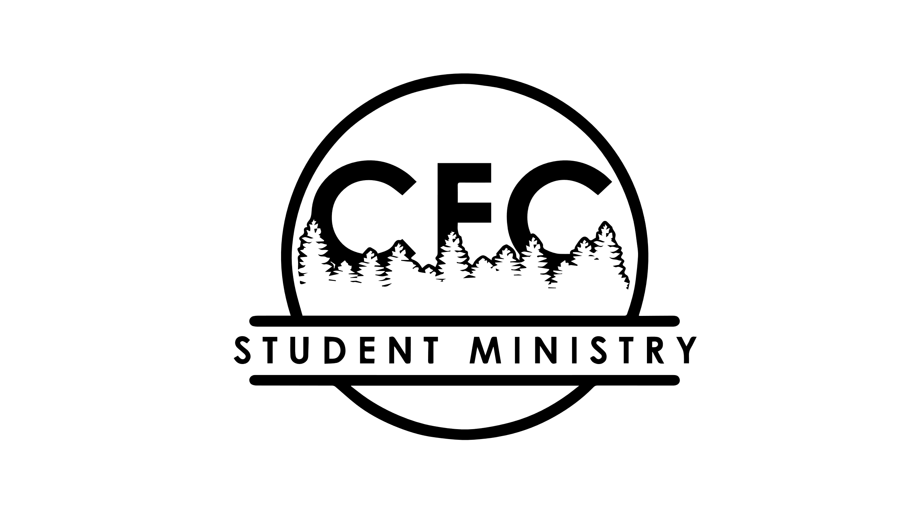
For God’s glory,

Jason Rohrbaugh  Minister of Youth  Christian Fellowship Church  rohrbaugh@cfcnewholland.org  717-354-8428 (office)  717-368-0217 (cell) | Rebecca Zimmerman  Student Ministries Administrative Assistant  Christian Fellowship Church  StudentAdmin@cfcnewholland.org
Follow us on Instagram! @cfcstudentmin

