Dear 7th and 8th grade students & parents,

Welcome (or welcome back) to Junior High! We hope you had a wonderful summer, and we look forward to spending time together again this school year!
Here’s what you can expect when Student Ministry (CFCSM) resumes in September:
SUNDAY MORNING “ENCOUNTER”: Our Sunday school ministry, which we call “Encounter”, is at 9:30am beginning on September 11th. This year, we will meet in the main youth room in the hallway behind the Gym just after all of the pastoral offices. The idea & emphasis is to encounter God & His written word on a more comprehensive basis than our other kinds of gatherings. This school year we will continue going through our 3-year Bible curriculum from The Gospel Project which we started last year, with some exceptions and mini-series at select times during the year.
WEDNESDAY NIGHT “TRANSFORM”: Beginning September 14th, on Wednesday nights from 7:00-8:20pm we’ll meet in the Gym & the newly renovated youth room! “Transform” is a time to relax and build relationships with each other and with God; its also a great opportunity to invite friends! We’ll play games, eat snacks, meet in small groups and have a time of biblical instruction.
“IMPACT”: Is a smaller part of Jr High student ministry, but one that we’re excited to see grow again this year. These are our intentional outreach and service events throughout the year. Opportunities to serve one another, our fellow believers, our neighbors, and reach out to those in need, those questioning life, & the unbelieving. We’re looking into ways to present opportunities for students to serve one another, this church family, our community, our missionaries & potentially partner with local ministries. Stay tuned for Impact events coming up this year!
CFCSM believes in having a healthy and sustainable ministry. We know that ministry needs to have its highs and lows (less busy times). For this school year we are currently planning to have 3 “high” ministry times. First, a “stay retreat” known as “Connect weekend” in October. Secondly, a Winter retreat in January 2023. And thirdly, summer mission tip/retreat camp in June or July 2023. Smaller one-day annual events are also being planned: like a Christmas party, Fall fest, & a winter Ski trip, & a movie night!

We’re excited for this upcoming year, and hope you are too! Please contact us with any & all questions you may have. See you in September!

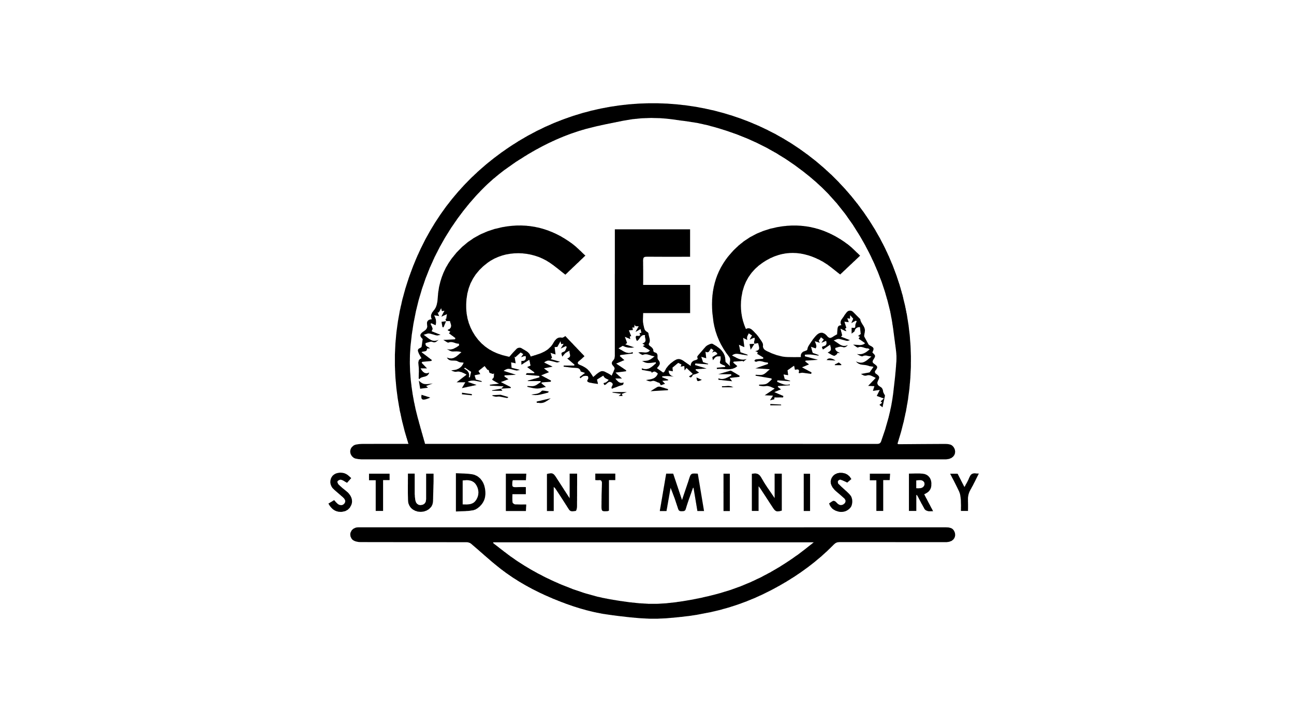
For God’s glory,

Jason Rohrbaugh  Minister of Youth  Christian Fellowship Church  rohrbaugh@cfcnewholland.org  717-354-8428 (office)  717-368-0217 (cell) | Rebecca Zimmerman  Student Ministries Administrative Assistant  Christian Fellowship Church  StudentAdmin@cfcnewholland.org
Follow us on Instagram! @cfcstudentmin

