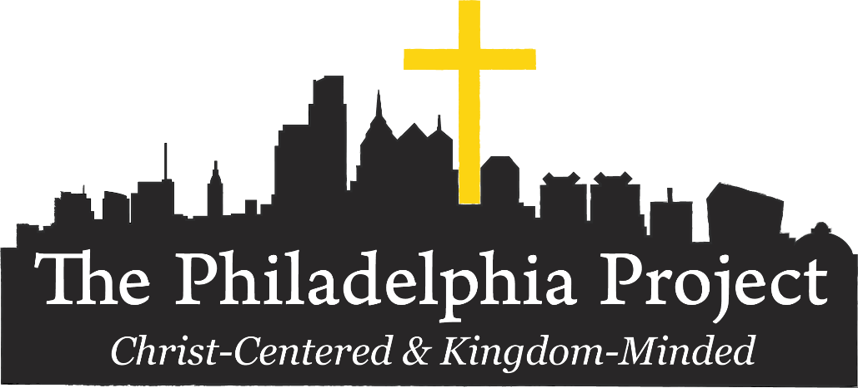

At the Philadelphia Project, we are moving forward with plans for Summer of Service (SOS) 2021!
SOS is our busiest time of year where we host around 100 youth group participants a week for 7 weeks every summer. We challenge youth to serve whole-heartedly in our community and to think critically about how God’s Word speaks to social and spiritual issues. Our prayer is that God uses this extended experience of service, worship, and fellowship to make an eternal impact on youth and those they serve as well as a visible impact offering hope and restoration to our community.

“Ministry Tracks”
Mercy Ministry
Participants will travel to different partner sites; they will package food for homebound citizens, serve meals to people experiencing homelessness, sort clothing at thrift shops, or service any other number of needs for one of our partner organizations.
Kids Camp
Participants will play with preschool through 6th graders at our partner churches, hang out with kids of all ages experiencing homelessness at a family shelter, or learn and grow with scholars at a nearby literacy program. This ministry track takes what might be familiar to participants—child care—and puts it in different contexts, giving participants a chance to see a little more of the world and begin to grasp the diversity of situations that children and families are coming from and live in every day.
Construction
This ministry is focused on giving participants the chance to be a part of tangible change in the lives of people they serve. Participants will follow the lead of one of our experienced staff or interns in a construction project in the home of one of our partner homeowners. We emphasize not only doing good construction work, but also engaging with the homeowners.

During the Week:
Our students will be involved in one of the above-mentioned ministry track 6+ hours a day for 5 days. Our youth group will always have CFC youth leaders and a Philadelphia Project staff member with them during the service time. Since we anticipate our group to be 30-35 people, we will have to divide into 3-4 different CFC groups, but CFC leaders will be with each group.

“Night out on the town” – an evening off during the week to relax, sightsee, and grab dinner together as a group in Philadelphia. Groups are responsible for all expenses during this time, including dinner and transportation. The Philadelphia Project can provide directions and suggestions for groups unfamiliar with the city.

CFC Youth Group Leaders
We anticipate 6 student leaders from CFC will be going on this mission’s trip. That could adjust depending on the number of students participating.

Who: Sr. High – students who have completed grades 9-12
When: June 27th – July 3rd (leave CFC Sunday afternoon and return to CFC Saturday noon)
Cost: $375 (deposit of $50 due with application. Remainder will be covered by fundraising efforts.)
Housing & Food: is provided by The Philadelphia Project starting Sunday evening to Saturday morning.

Overview of Important Dates & Info

Students applying to go on this missions trip should be attending CFC youth group regularly so they are developing group community before and after the mission trip.

April 25th: Application and Deposit Due. Both the application and $50 deposit (cash or check made out to CFC) can be submitted to the church office.

April 25th: Online Registration Due. Go on The Philadelphia Project’s website (https://thephiladelphiaproject.com/plan-a-trip/summer-of-service/) and click on the “Quick Link” Student Medical & Photo Release (located at the bottom of the page) and fill out the online student medical & photo release form for The Philadelphia Project so that they have all of your info.

May 16th: Missions Trip Fund Raiser & Prayer Support Breakfast
- Help prepare & serve a Continental Breakfast (8:15-9:15 am) at CFC. (this will most likely be just pastries, coffee, juice, etc.)
- Students will briefly share the challenges & opportunities this missions trip provides them in front of the group.
- All students going are expected to attend and participate.
- A few parents will be needed to help lead this event from behind the scenes.
- Money donated will be put towards the missions costs of the students that participate.
(we anticipate all costs beyond initial deposit will be raised)

By May 31th
Students & Leaders send a letter to each of your prayer support people sharing the dates of the project and your prayer requests (send by email or snail mail).

June 27th-July 3rd – The Philadelphia Project Trip leaves Sunday morning (June 27) and will return by noon on Saturday (July 3)

Questions about details contact: Rebecca Zimmerman: studentadmin@cfcnewholland.org or
Jason Rohrbaugh: rohrbaugh@cfcnewholland.org
717-368-0217

