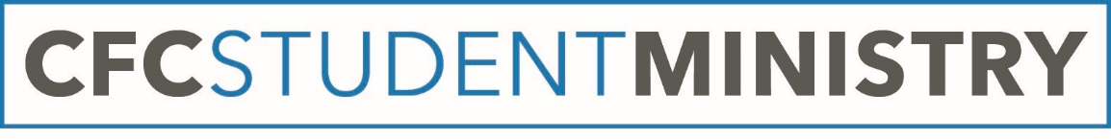
Welcome to Youth Group! (Or welcome back, if you were with us last year!) We’re pumped for this upcoming year, and hope you are too. We want to make sure our information is up-to-date because things often change; we’d really appreciate if you fill out this form and get it back to us so we can keep in communication with you and your parents/guardians about events and important messages throughout the year. Thanks for your help!
The student ministry events for the current month, as well as snack signups and important documents (like an up-to-date calendar or waivers) can be found on CFC’s website:
cfcnewholland.org/content/student-ministries
(From the home page, click on “ministries” then “student ministries” and it will take you right there.)

And of course, we would love to hear from you if you have any questions or concerns! Contact information is listed below:

Jason Rohrbaugh
Minister of Youth
rohrbaugh@cfcnewholland.org
jason4cfc@yahoo.com
717-368-0217

Rebecca Zimmerman
Student Ministries Administrative Assistant
studentadmin@cfcnewholland.org

CFC Office
717-354-2404

Please tear off the following section and return to a youth leader or the church office:

Your name:____________________________________________________ Your grade:____________
Your birthday (mm/dd/yyyy):____________________Your address: ____________________________ _____________________________________________________________________________________
Please fill out at least one of the following:

Parent/guardian name:___________________ _______________________________________
Phone number:__________________________
Email address: __________________________ _______________________________________
Parent/guardian name:___________________ _______________________________________
Phone number:__________________________
Email address: __________________________ _______________________________________

